N-gonal Pyramid

Definition
# Source: AI Source: Provided by: [Data Path: Persons Table -> ID Column: 1, Name_En Column: Motasem Essam] -> From: [ChatGPT] on [7/25/2026]
An $n$-gonal pyramid is a three-dimensional geometric solid with one polygonal base containing $n$ sides and $n$ triangular lateral faces that meet at a common point called the apex.
The letter $n$ represents the number of sides of the base polygon, where $n≥3$.
Examples include:
- Triangular pyramid: $n=3$
- Quadrilateral pyramid: $n=4$
- Pentagonal pyramid: $n=5$
- Hexagonal pyramid: $n=6$
- Heptagonal pyramid: $n=7$
- Octagonal pyramid: $n=8$
An $n$-gonal pyramid generalizes all pyramids with polygonal bases. Its base may be regular or irregular, and its apex may be positioned to form a right or oblique pyramid.
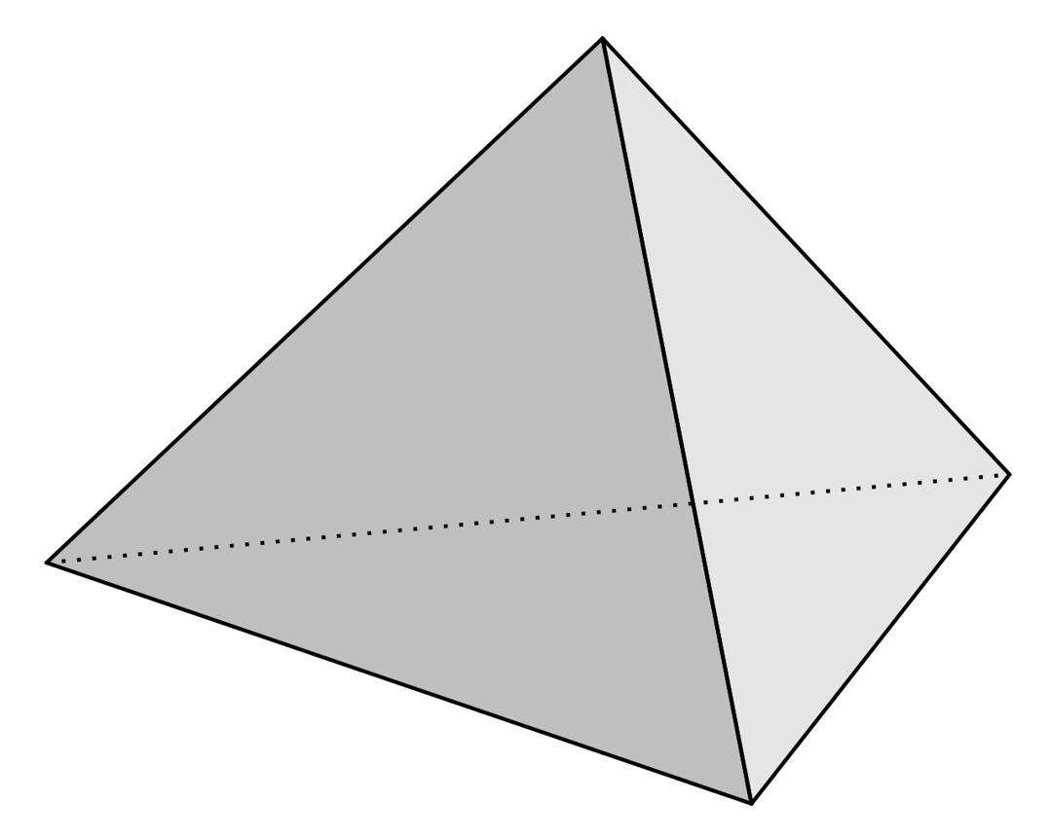
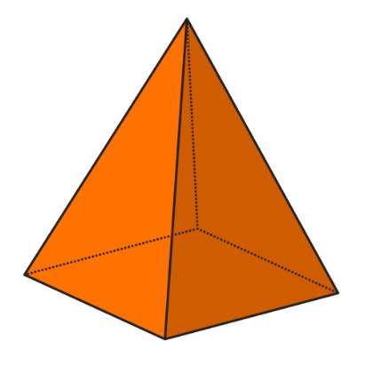
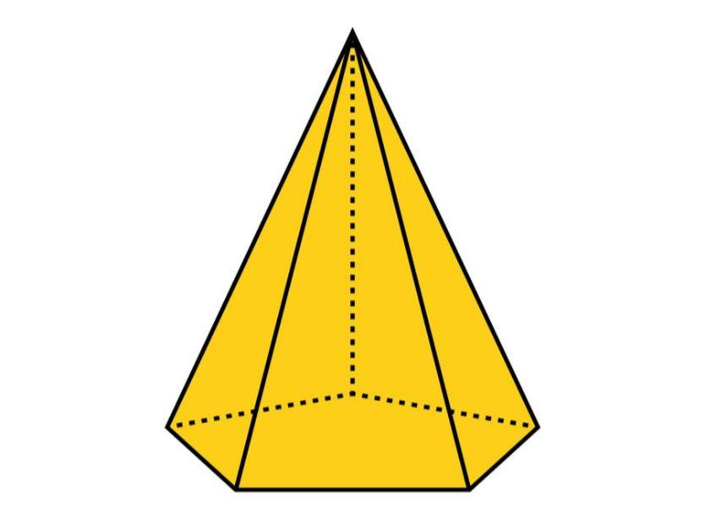

Simple Definition
# Source: AI Source: Provided by: [Data Path: Persons Table -> ID Column: 1, Name_En Column: Motasem Essam] -> From: [ChatGPT] on [7/25/2026]
An $n$-gonal pyramid is a pyramid whose base has $n$ sides. Each base vertex is connected to the same apex, creating $n$ triangular lateral faces.
For example, a pyramid with a hexagonal base is a 6-gonal pyramid because its base has six sides.

Classification Tree
# Source: AI Source: Provided by: [Data Path: Persons Table -> ID Column: 1, Name_En Column: Motasem Essam] -> From: [ChatGPT] on [7/25/2026]
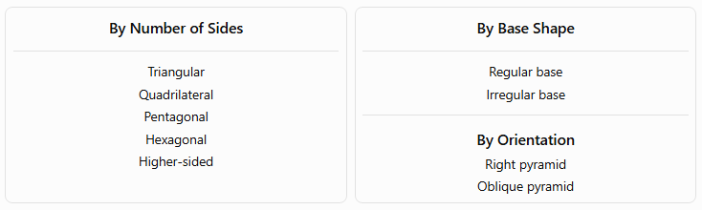
By Number of Sides
Triangular
Quadrilateral
Pentagonal
Hexagonal
Higher-sided
By Base Shape
Regular base
Irregular base
By Orientation
Right pyramid
Oblique pyramid

By Number of Base Sides
# Source: AI Source: Provided by: [Data Path: Persons Table -> ID Column: 1, Name_En Column: Motasem Essam] -> From: [ChatGPT] on [7/25/2026]
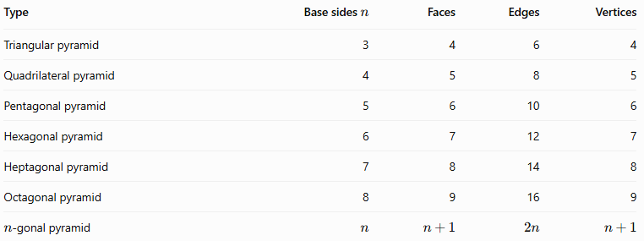
Type | Base sides $n$ | Faces | Edges | Vertices
Triangular pyramid | 3 | 4 | 6 | 4
Quadrilateral pyramid | 4 | 5 | 8 | 5
Pentagonal pyramid | 5 | 6 | 10 | 6
Hexagonal pyramid | 6 | 7 | 12 | 7
Heptagonal pyramid | 7 | 8 | 14 | 8
Octagonal pyramid | 8 | 9 | 16 | 9
$n$-gonal pyramid | $$n$$ | $$n+1$$ | $$2n$$ | $$n+1$$

B. By Base Shape
# Source: AI Source: Provided by: [Data Path: Persons Table -> ID Column: 1, Name_En Column: Motasem Essam] -> From: [ChatGPT] on [7/25/2026]
- Regular $n$-gonal pyramid: Has a regular polygon as its base. A regular polygon has equal sides and equal interior angles. When the apex is directly above the base center, the pyramid is a regular right pyramid, with congruent lateral faces.
- Irregular $n$-gonal pyramid: Has an irregular polygon as its base. Its base edges or interior angles are not all equal, and its lateral faces need not be congruent.

C. By Spatial Orientation
# Source: AI Source: Provided by: [Data Path: Persons Table -> ID Column: 1, Name_En Column: Motasem Essam] -> From: [ChatGPT] on [7/25/2026]
- Right $n$-gonal pyramid: The perpendicular from the apex meets the base at its center. For a regular base, this produces the usual symmetrical right pyramid.
- Oblique $n$-gonal pyramid: The apex is offset from the base center, so the lateral edges and faces are generally unequal.

Key Characteristics
# Source: AI Source: Provided by: [Data Path: Persons Table -> ID Column: 1, Name_En Column: Motasem Essam] -> From: [ChatGPT] on [7/25/2026]
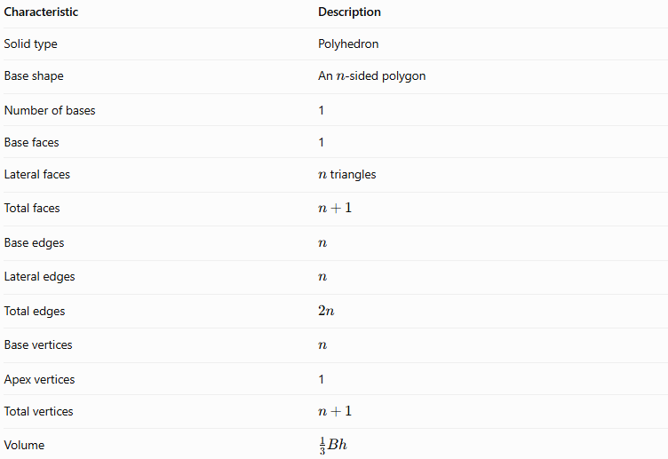
Characteristic | Description
Solid type | Polyhedron
Base shape | An $n$-sided polygon
Number of bases | 1
Base faces | 1
Lateral faces | $n$ triangles
Total faces | $$n+1$$
Base edges | $$n$$
Lateral edges | $$n$$
Total edges | $$2n$$
Base vertices | $$n$$
Apex vertices | 1
Total vertices | $$n+1$$
Volume | $$\frac{1}{3}Bh$$

Geometric Representation
# Source: AI Source: Provided by: [Data Path: Persons Table -> ID Column: 1, Name_En Column: Motasem Essam] -> From: [ChatGPT] on [7/25/2026]
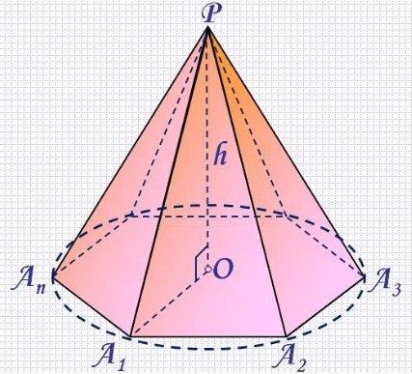
Consider an $n$-gonal pyramid with apex $S$ and base vertices $A_{1},A_{2},…,A_{n}$.
Its components are:
- Base: The polygon $A_{1}A_{2}…A_{n}$, containing $n$ sides.
- Apex $S$: The single vertex connected to every base vertex.
- Base edges: The $n$ edges around the polygon.
- Lateral edges: The $n$ segments joining each base vertex to $S$.
- Lateral faces: The $n$ triangular faces $SA_{i}A_{i+1}$, with indices wrapping around so that $A_{n+1}=A_{1}$.
- Height $h$: The perpendicular distance from the apex to the plane of the base.
- Slant height $l$: For a regular right pyramid, the perpendicular distance from the apex to the midpoint of a base edge along a lateral face.

Mathematical Representations and Formulas
# Source: AI Source: Provided by: [Data Path: Persons Table -> ID Column: 1, Name_En Column: Motasem Essam] -> From: [ChatGPT] on [7/25/2026]
Let:
- $n$ = number of sides of the base
- $B$ = area of the base
- $p$ = perimeter of the base
- $h$ = perpendicular height
- $l$ = face slant height for a regular right pyramid

A. Number of faces, edges, and vertices
# Source: AI Source: Provided by: [Data Path: Persons Table -> ID Column: 1, Name_En Column: Motasem Essam] -> From: [ChatGPT] on [7/25/2026]
For every $n$-gonal pyramid:
$$\boxed{F=n+1}$$
$$\boxed{E=2n}$$
$$\boxed{V_{e}=n+1}$$
Here, $F$ is the number of faces, $E$ is the number of edges, and $V_{e}$ is the number of vertices.

B. Base perimeter
# Source: AI Source: Provided by: [Data Path: Persons Table -> ID Column: 1, Name_En Column: Motasem Essam] -> From: [ChatGPT] on [7/25/2026]
For a general polygonal base with side lengths $a_{1},a_{2},…,a_{n}$:
$$\boxed{p=\sum_{i=1}^{n}{a_{i}}}$$
For a regular $n$-gonal base with side length $a$:
$$\boxed{p=na}$$

C. Base area
# Source: AI Source: Provided by: [Data Path: Persons Table -> ID Column: 1, Name_En Column: Motasem Essam] -> From: [ChatGPT] on [7/25/2026]
For a regular $n$-gonal base with side length $a$:
$$\boxed{B=\frac{na^{2}}{4\tan\left(π/n\right)}}$$
If the base apothem is $r$, the area can also be calculated as:
$$\boxed{B=\frac{1}{2}pr}$$
For an irregular polygon, the base area must be calculated using a method appropriate to its shape, such as dividing it into triangles.

D. Volume
# Source: AI Source: Provided by: [Data Path: Persons Table -> ID Column: 1, Name_En Column: Motasem Essam] -> From: [ChatGPT] on [7/25/2026]
The volume of any pyramid is one-third the base area multiplied by the perpendicular height:
$$\boxed{V=\frac{1}{3}Bh}$$
For a regular $n$-gonal pyramid:
$$\boxed{V=\frac{na^{2}h}{12\tan\left(π/n\right)}}$$

E. Lateral surface area
# Source: AI Source: Provided by: [Data Path: Persons Table -> ID Column: 1, Name_En Column: Motasem Essam] -> From: [ChatGPT] on [7/25/2026]
For any $n$-gonal pyramid, the lateral surface area is the sum of the areas of its $n$ triangular faces:
$$\boxed{A_{L}=\sum_{i=1}^{n}{A_{i}}}$$
For a regular right $n$-gonal pyramid, all lateral faces are congruent, giving:
$$\boxed{A_{L}=\frac{1}{2}pl}$$
Since $p=na$:
$$\boxed{A_{L}=\frac{1}{2}nal}$$

F. Total surface area
# Source: AI Source: Provided by: [Data Path: Persons Table -> ID Column: 1, Name_En Column: Motasem Essam] -> From: [ChatGPT] on [7/25/2026]
The total surface area includes the base and all lateral faces:
$$\boxed{A_{T}=B+A_{L}}$$
For a regular right $n$-gonal pyramid:
$$\boxed{A_{T}=\frac{na^{2}}{4\tan\left(π/n\right)}+\frac{1}{2}nal}$$

G. Slant height relationship
# Source: AI Source: Provided by: [Data Path: Persons Table -> ID Column: 1, Name_En Column: Motasem Essam] -> From: [ChatGPT] on [7/25/2026]
For a regular right $n$-gonal pyramid, the height, face slant height, and base apothem form a right triangle:
$$\boxed{l=\sqrt{h^{2}+r^{2}}}$$
This formula applies when the apex is directly above the center of a regular base.

H. Euler's formula
# Source: AI Source: Provided by: [Data Path: Persons Table -> ID Column: 1, Name_En Column: Motasem Essam] -> From: [ChatGPT] on [7/25/2026]
Every convex $n$-gonal pyramid satisfies Euler's formula:
$$\boxed{V_{e}-E+F=2}$$
Substituting the general counts:
$$\left(n+1\right)-2n+\left(n+1\right)=2$$
Therefore, the formula holds for every convex $n$-gonal pyramid.

Worked Examples
# Source: AI Source: Provided by: [Data Path: Persons Table -> ID Column: 1, Name_En Column: Motasem Essam] -> From: [ChatGPT] on [7/25/2026]
Example 1: Finding the number of faces, edges, and vertices
Problem: Find the geometric element counts for a 9-gonal pyramid.
Solution: Since $n=9$:
$$F=9+1=10$$
$$E=2\left(9\right)=18$$
$$V_{e}=9+1=10$$
Answer: 10 faces, 18 edges, and 10 vertices.
Example 2: Finding the volume
Problem: An $n$-gonal pyramid has a base area of $96{\text{ cm}}^{2}$ and a perpendicular height of $15\text{ cm}$. Find its volume.
Solution:
$$V=\frac{1}{3}Bh$$
$$V=\frac{1}{3}\left(96\right)\left(15\right)$$
$$\boxed{V=480{\text{ cm}}^{3}}$$
The volume formula works regardless of the number of sides in the base.
Example 3: Calculating the base area of a regular octagonal pyramid
Problem: A regular octagonal pyramid has a base side length of $4\text{ cm}$. Find its base area.
Solution: An octagon has $n=8$ sides.
$$B=\frac{na^{2}}{4\tan\left(π/n\right)}$$
$$B=\frac{8{\left(4\right)}^{2}}{4\tan\left(π/8\right)}$$
$$B=\frac{32}{\tan\left({22.5}^{∘}\right)}$$
$$\boxed{B≈77.25{\text{ cm}}^{2}}$$
Example 4: Finding lateral surface area
Problem: A regular right 7-gonal pyramid has a base side length of $3\text{ cm}$ and a slant height of $10\text{ cm}$. Find its lateral surface area.
Solution:
First, calculate the base perimeter:
$$p=na=7\left(3\right)=21\text{ cm}$$
Then calculate the lateral surface area:
$$A_{L}=\frac{1}{2}pl$$
$$A_{L}=\frac{1}{2}\left(21\right)\left(10\right)$$
$$\boxed{A_{L}=105{\text{ cm}}^{2}}$$
Example 5: Verifying Euler's formula
Problem: Verify Euler's formula for a 9-gonal pyramid.
From Example 1:
$$V_{e}=10, E=18, F=10$$
Substitute:
$$V_{e}-E+F=10-18+10=2$$
Answer: Euler's formula is satisfied.

Comparison with Related Geometric Solids
# Source: AI Source: Provided by: [Data Path: Persons Table -> ID Column: 1, Name_En Column: Motasem Essam] -> From: [ChatGPT] on [7/25/2026]
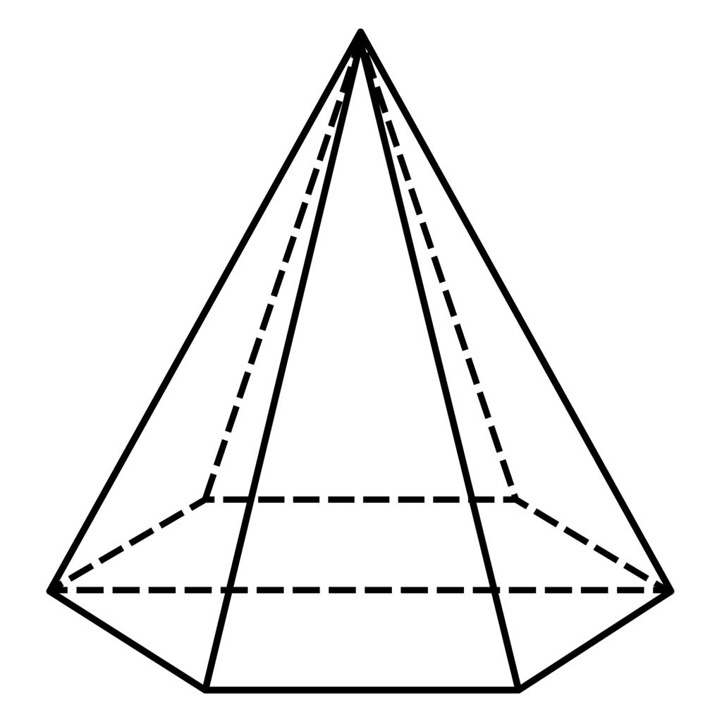
$n$-gonal Pyramid
- One polygonal base.
- $n$ triangular lateral faces.
- $n+1$ faces, $2n$ edges, $n+1$ vertices.
- Volume: $\frac{1}{3}Bh$.
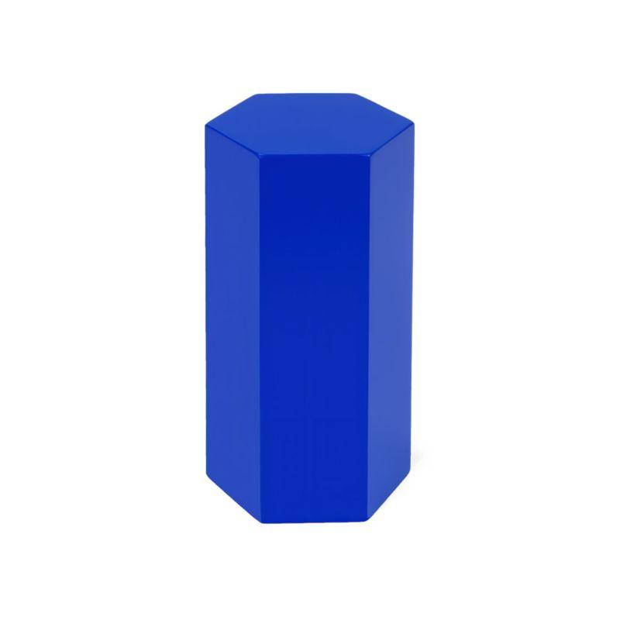
$n$-gonal Prism
- Two congruent polygonal bases.
- $n$ lateral faces.
- $n+2$ faces, $3n$ edges, $2n$ vertices.
- Volume: $Bh$.
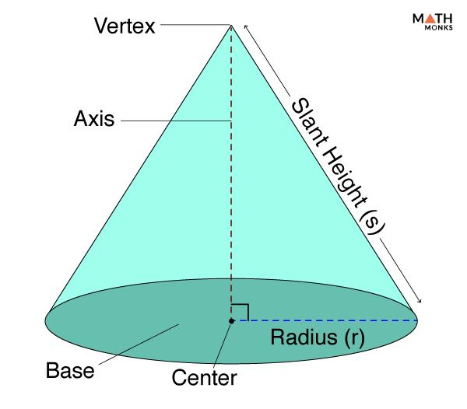
Cone
- One circular base.
- One continuous curved lateral surface.
- One apex and a circular rim rather than polygonal edges.
- Volume: $\frac{1}{3}πr^{2}h$.

Constructing N-gonal Pyramid in Solid Geometry

Instruments Used
# Source: AI Source: Provided by: [Data Path: Persons Table -> ID Column: 1, Name_En Column: Motasem Essam] -> From: [ChatGPT] on [7/25/2026]
The construction uses physical geometric drawing instruments rather than coordinate-based methods.
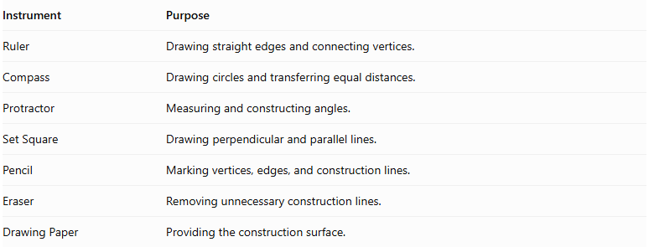
Instrument | Purpose
Ruler | Drawing straight edges and connecting vertices.
Compass | Drawing circles and transferring equal distances.
Protractor | Measuring and constructing angles.
Set Square | Drawing perpendicular and parallel lines.
Pencil | Marking vertices, edges, and construction lines.
Eraser | Removing unnecessary construction lines.
Drawing Paper | Providing the construction surface.

Construction Procedures

Base-Based Construction
# Source: AI Source: Provided by: [Data Path: Persons Table -> ID Column: 1, Name_En Column: Motasem Essam] -> From: [ChatGPT] on [7/25/2026]
- Determine the number of sides $n$ required for the polygonal base.
- Draw the N-gonal base using a ruler, compass, and protractor.
- Identify and mark its $n$ vertices.
- Determine the position of the apex above or away from the base.
- Connect the apex to each of the $n$ base vertices.
- Complete the $n$ triangular lateral faces.
- Darken the visible edges and use dashed lines for hidden edges.

Apex-Based Construction
# Source: AI Source: Provided by: [Data Path: Persons Table -> ID Column: 1, Name_En Column: Motasem Essam] -> From: [ChatGPT] on [7/25/2026]
- Mark the intended apex position.
- Draw the N-gonal base beneath the apex.
- Identify the $n$ base vertices.
- Connect each base vertex to the apex.
- Complete the lateral triangular faces.

Vertex-Connection Construction
# Source: AI Source: Provided by: [Data Path: Persons Table -> ID Column: 1, Name_En Column: Motasem Essam] -> From: [ChatGPT] on [7/25/2026]
- Construct the $n$ vertices of the polygonal base.
- Mark the apex as the $(n+1)$th vertex.
- Connect the apex to all $n$ base vertices.
- Connect consecutive base vertices to complete the polygonal base.
- Check that all edges and faces form a closed solid.

Edge-Based Construction
# Source: AI Source: Provided by: [Data Path: Persons Table -> ID Column: 1, Name_En Column: Motasem Essam] -> From: [ChatGPT] on [7/25/2026]
- Draw the $n$ edges of the polygonal base.
- Determine the $n$ lateral edges extending from the base vertices to the apex.
- Construct and connect the lateral edges.
- Complete the triangular lateral faces.

Face-Based Construction
# Source: AI Source: Provided by: [Data Path: Persons Table -> ID Column: 1, Name_En Column: Motasem Essam] -> From: [ChatGPT] on [7/25/2026]
- Construct the N-gonal base.
- Draw $n$ triangular faces around the base.
- Connect the corresponding vertices and edges.
- Ensure that all $n$ triangular faces meet at the apex.

Net-Based Construction
# Source: AI Source: Provided by: [Data Path: Persons Table -> ID Column: 1, Name_En Column: Motasem Essam] -> From: [ChatGPT] on [7/25/2026]
- Draw one N-gonal base.
- Construct $n$ triangular faces around the polygon.
- Add tabs if necessary for physical assembly.
- Cut out the net.
- Fold the triangular faces upward.
- Join their edges to form the N-gonal pyramid.
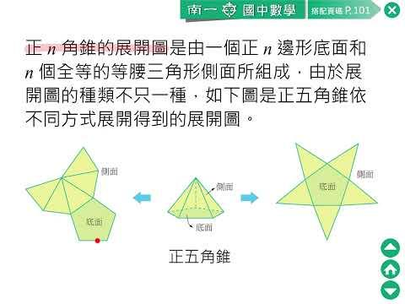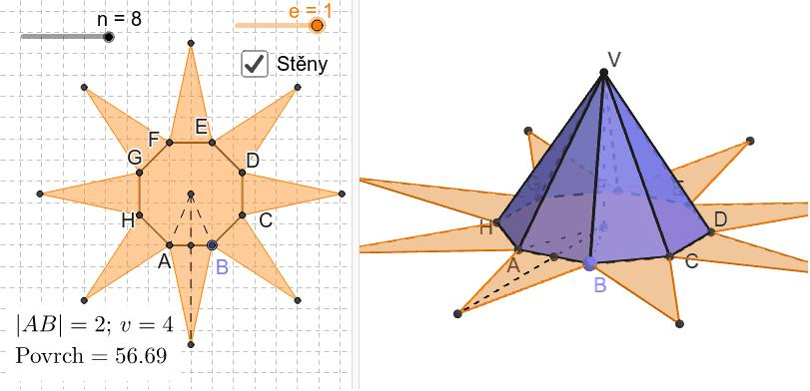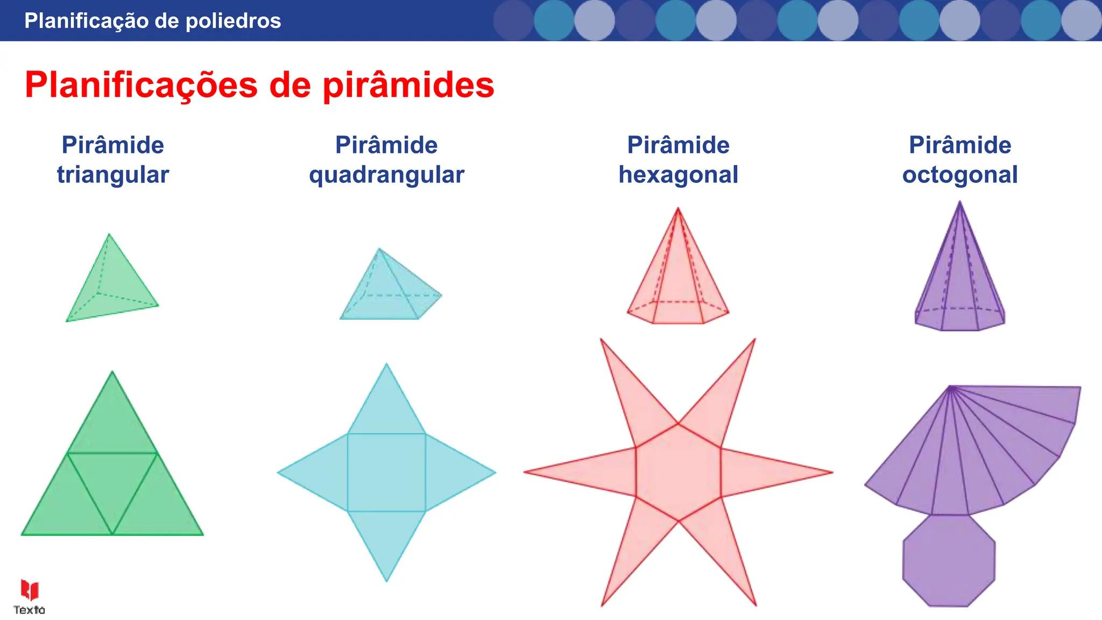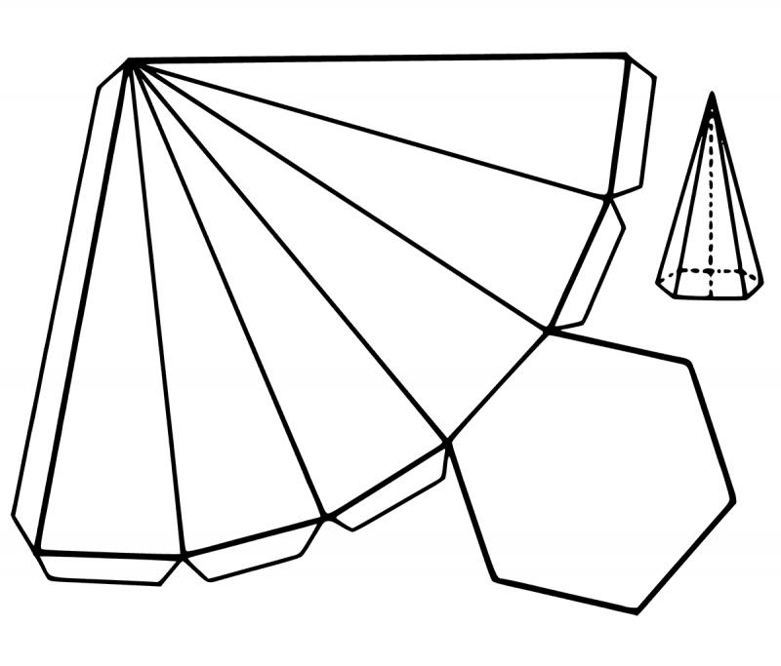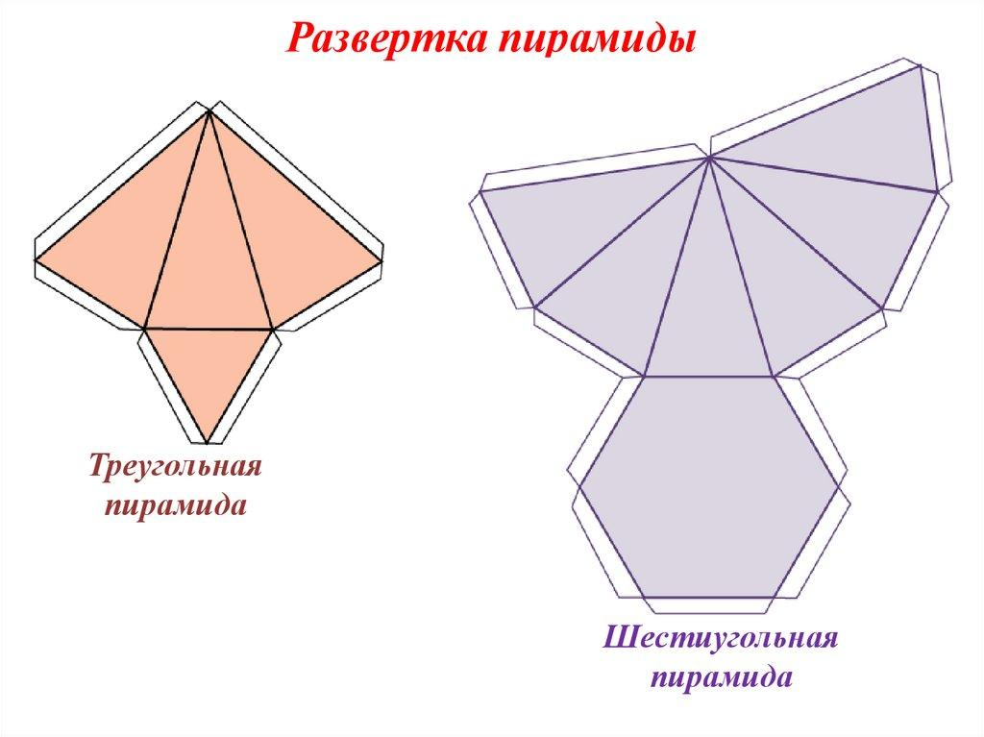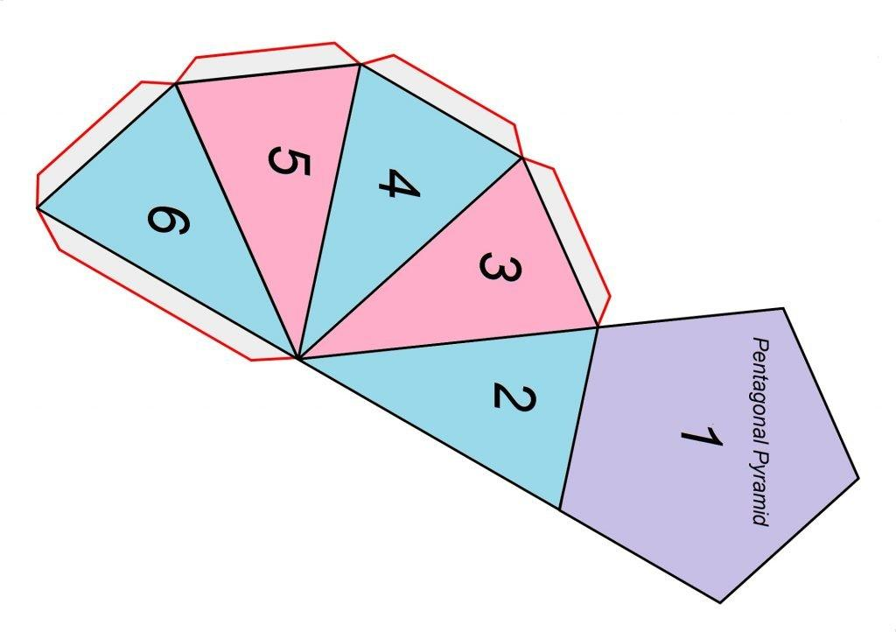

Applications
# Source: AI Source: Provided by: [Data Path: Persons Table -> ID Column: 1, Name_En Column: Motasem Essam] -> From: [ChatGPT] on [7/25/2026]
The concept of an $n$-gonal pyramid is useful in:
- Architecture: Designing pyramid roofs and structures with different polygonal footprints.
- Engineering: Calculating the volume and surface area of tapered components.
- Computer graphics: Constructing polygon meshes for 3D objects.
- Mathematics education: Generalizing geometric formulas from triangular and square-based pyramids to any polygonal base.
- Packaging and product design: Creating tapered containers and decorative objects with polygonal bases.

Key Points
# Source: AI Source: Provided by: [Data Path: Persons Table -> ID Column: 1, Name_En Column: Motasem Essam] -> From: [ChatGPT] on [7/25/2026]
- $n$ represents the number of sides of the polygonal base, with $n≥3$.
- An $n$-gonal pyramid has $n+1$ faces, $2n$ edges, and $n+1$ vertices.
- It has one base and $n$ triangular lateral faces.
- Its volume is $V=\frac{1}{3}Bh$.
- For a regular right pyramid, its lateral surface area is $A_{L}=\frac{1}{2}pl$.
- A regular base does not by itself guarantee a right pyramid; the apex must also be positioned above the base center.
- Every convex $n$-gonal pyramid satisfies Euler's formula.

Conclusion
# Source: AI Source: Provided by: [Data Path: Persons Table -> ID Column: 1, Name_En Column: Motasem Essam] -> From: [ChatGPT] on [7/25/2026]
An $n$-gonal pyramid is the general form of a pyramid whose base has any number $n$ of sides, starting with three. Its formulas describe the faces, edges, vertices, volume, and surface area of triangular, quadrilateral, pentagonal, hexagonal, and higher-sided pyramids within one mathematical framework. It is therefore a fundamental concept for understanding and classifying pyramids in solid geometry.

